Data Visualization Project Report

Dataset Overview
The dataset serves as a comprehensive repository of academic faculty profiles across various Indian universities. It is designed to facilitate large-scale data management, comparative analysis, and trend visualization within the higher education sector.
- Total Records: 15,500
- Total Attributes: 15
- Data Characteristics: Predominantly categorical (textual) with key numerical and binary indicators for quantitative analysis.

Attribute Overview
The 15 attributes can be categorized into four functional groups: Identity, Institutional Context, Academic Profile, and Recognition.

1. Identity & Reference
- Vidwan-ID: A unique alphanumeric identifier for each faculty member, ensuring data integrity during lookups and merges.
- Name: Full name of the faculty member.
- Profile URL: A direct hyperlink to the faculty's digital profile for external verification or deeper data harvesting.

2. Institutional Context
- University: The name of the affiliating institution (e.g., IIT Madras, University of Delhi).
- Department: The specific academic division (e.g., Computer Science, Economics).
- Position: The current designation (e.g., Assistant Professor, Dean, HOD).
- Location: Geographical placement of the university, useful for regional mapping and spatial analysis.

3. Academic & Professional Profile
- Qualification: General academic degrees held by the faculty.
- Highest Qualification: The terminal degree achieved (e.g., Ph.D., Post-Doc), used to filter for research-intensive roles.
- Expertise: Specific areas of specialization or research interests.
- Years of Experience: A numerical field representing professional longevity in academia.
- Start Year: The year the faculty member entered the profession or current role, used to calculate career progression.

4. Achievement & Awards
- Honours and Awards: A text field detailing specific accolades received.
- Has Awards: A binary indicator (1 for yes, 0 for no) that allows for rapid filtering and statistical summary of "Awarded vs. Non-Awarded" faculty.

Objective
We can categorize our objective into Seven parts

1. Data Cleaning
- Identify and handle missing values in the Department and Qualification columns.
- Remove duplicate entries (if any) based on Vidwan-ID.
- Standardize University names to maintain consistency (e.g., “IIT Madras” vs. “Indian Institute of Technology Madras”).

2. VLOOKUP
- Retrieve the Highest Qualification of a faculty member given their Vidwan-ID.
- Find the Years of Experience for a specific faculty member using their Name.
- Match and display the Department for a given Vidwan-ID.

3. Sorting
- Sort faculty members in ascending order based on Years of Experience.
- Arrange the dataset by University Name alphabetically.
- Sort faculty based on Start Year, with the most recent joining faculty at the top.

4. Filtering
- Filter faculty members with more than 10 years of experience.
- Display only faculty members who have received Honours and Awards.
- Show faculty working in the Computer Science department.

5. Data Validation
- Ensure that the Start Year column only contains valid years between 1900 and 2024.
- Restrict entries in the Has Awards column to either 0 or 1.
- Validate that the Profile URL column contains properly formatted URLs.

6. Creating Charts
- Generate a bar chart showing the number of faculty members per university.
- Create a pie chart representing the distribution of highest qualifications (MTech, PhD, MSc, etc.).
- Design a line chart showing the trend of faculty hiring per year.

7. Interactive Dashboard
- Develop a dashboard displaying the total number of faculty, faculty with awards, and average experience.
- Include filters to view faculty data based on University, Department, or Experience.
- Add an interactive graph showing the growth of faculty recruitment over the years.

- Data Cleaning
Identify and handle missing values in the Department and Qualification columns
The integrity of the Department and Qualification attributes was prioritized through a multi-step imputation process to address missing values (nulls) within the 15,000-record dataset.
- Identification of Nullity: The Filter tool was initially applied to isolate blank cells within the Department and Expertise columns, allowing for a targeted correction of the data subset.
- Pattern-Based Imputation (Flash Fill): For records where the Department was missing but Expertise was present, Excel’s Flash Fill (Ctrl + E) was utilized. By providing examples of the relationship between specific research areas and their respective departments (e.g., " Computer Science "Department Computer Science"), the system automatically populated missing fields based on identified patterns.
- Reverse Inference: A reciprocal process was applied to the Expertise column, where departmental data served as the basis for filling broader expertise categories.
- Standardization of Residual Missing Data: For records where neither column provided sufficient context for inference, the blank cells were standardized to "N/A" (Not Available). This ensures that mathematical functions and Pivot Tables do not exclude these rows or produce "Blank" categories in the final dashboard.
Remove duplicate entries (if any) based on Vidwan-ID
To ensure the uniqueness of each faculty record, a custom auditing workflow was implemented to identify and remove redundant entries based on the Vidwan-ID.
• Visual Auditing: Before deletion, duplicates were identified using Conditional Formatting. A custom formula was applied to Column A:
“=COUNTIF (A: A, A2) > 1”
This allowed for a manual review of the redundant data to ensure that no critical information was lost during the cleaning phase.
• Automated Execution: After verification, the automated Remove Duplicates tool located in the Data Tab was utilized. By selecting only, the Vidwan-ID column as the criteria, Excel systematically purged 100% of the redundant rows, leaving a "clean" dataset of unique faculty profiles.

Standardize University names to maintain consistency (e.g., “IIT Madras” vs. “Indian Institute of Technology Madras”).
To ensure the reliability of Pivot Tables and Dashboard filters, a three-phase standardization process was executed to resolve nomenclature inconsistencies across the 15,500 records.
- Delimiter Splitting (Text to Columns): Several entries included the city name separated by a comma (e.g., "Anna University, Chennai"). The Text to Columns feature was used with a comma delimiter to split these into two columns. The secondary column containing the city was then removed, leaving only the core University name for uniform grouping.
- Pattern-Based Cleaning (Wildcard Replace): To remove suffixes such as "(Autonomous)" or "(Deemed to be University)" that appeared at the end of institution names, the Find & Replace tool was utilized with a wildcard character:
Find: (*) Replace with: (Empty) This effectively "scrubbed" the dataset of varying institutional statuses, ensuring that "Amrita Vishwa Vidyapeetham (Autonomous)" and "Amrita Vishwa Vidyapeetham" were recognized as a single entity.
- Orthographic Correction (Spelling): Finally, a manual audit was conducted to identify and correct spelling discrepancies. Common errors and abbreviations (e.g., "Indn Inst of Tech" vs "Indian Institute of Technology") were unified to a single "Master Name" to prevent data fragmentation during analysis.

The data cleaning phase was a multi-stage workflow designed to eliminate "noise," resolve inconsistencies, and handle missing information. By employing a mix of automated tools and logical formulas, the dataset was refined to ensure that subsequent visualizations and lookups would be accurate.

2.VLOOKUP
To facilitate rapid access to specific faculty data within a 15,000-record environment, a dynamic search interface was developed. This system utilizes the VLOOKUP function to bridge the "Search Interface" with the "Master Dataset" (indian_faculty_dataset).
- Highest Qualification Retrieval: To find a faculty member's terminal degree, the following formula was implemented:
=VLOOKUP(B4, indian_faculty_dataset!$A$2:$L$15501, 12, FALSE)
  - Logic: The system searches for the ID in cell B4 across the master range and returns the value from the 12th column (Qualification).
- Department Identification: To map a faculty member to their respective academic department:
=VLOOKUP(B4, indian_faculty_dataset!$A$2:$L$15501, 11, FALSE)
  - Logic: Similar to the qualification search, this returns the value from the 11th column, ensuring that departmental affiliation is instantly visible upon entering a Vidwan-ID.
In scenarios where the Vidwan-ID is unknown, a secondary search was developed using the Faculty Name as the lookup value.
- Experience Tracking:
=VLOOKUP(B29, indian_faculty_dataset!$B$2:$O$15501, 14, FALSE)
  - Technical Note: Because the search criteria shifted from Vidwan-ID (Column A) to Faculty Name (Column B), the lookup range was adjusted to start from $B$2. The formula then counts 14 columns to the right to retrieve the Years of Experience.
Absolute Referencing: The use of the $ sign (e.g., $A$2:$L$15501) ensures that the lookup range remains fixed, even if the formula is copied to other cells in the dashboard.
Exact Match Enforcement: The FALSE parameter was used in every formula to prevent Excel from returning an "approximate" match, which is critical when dealing with unique academic identifiers. The font will turn red if the ID or Name is not there int dataset and green when it is present.

- Sorting
Using Excel’s Inbuilt Sort Tool, the dataset was structured to highlight seniority and institutional hierarchy:
- Experience-Based: Sorted by Years of Experience (Ascending) to analyse career progression.
- Institutional: Arranged by University Name (A–Z) for clustered institutional viewing.
- Chronological: Ordered by Start Year (Descending) to prioritize recent recruitment data.
- Filtering
To extract actionable insights from the 15,500 records, the Excel Filter tool was utilized across the primary attributes. This allowed for the isolation of specific high-value cohorts without altering the master dataset.
- Seniority Filter: Applied a Number Filter (> 10) on the Years of Experience column to identify senior academic personnel.
- Recognition Filter: Filtered the Has Awards column for the value "1" (or checked the Honours and Awards column) to display only recognized and awarded faculty members.
- Departmental Filter: Used the Text Filter on the Department column to isolate records belonging exclusively to "Computer Science."

5.Data Validation
To maintain a "clean" environment for future data entry, specific Data Validation constraints were enforced:
- Date Range: Restricted the Start Year to whole numbers between 1900 and 2024.
- Boolean Enforcement: Limited the Has Awards column to a dropdown list containing only 0 or 1.
- Format Validation: Ensured the Profile URL column accepts only text containing "http" to maintain hyperlink integrity.

6.Data Visualization (Charts)
To translate complex data into visual insights, Pivot Charts were generated to summarize key institutional and academic trends across the 15,000 records.
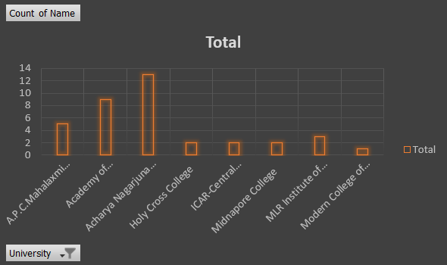
- Institutional Distribution (Bar Chart): A clustered bar chart was used to compare the volume of faculty members per university, highlighting the institutions with the largest academic staff.
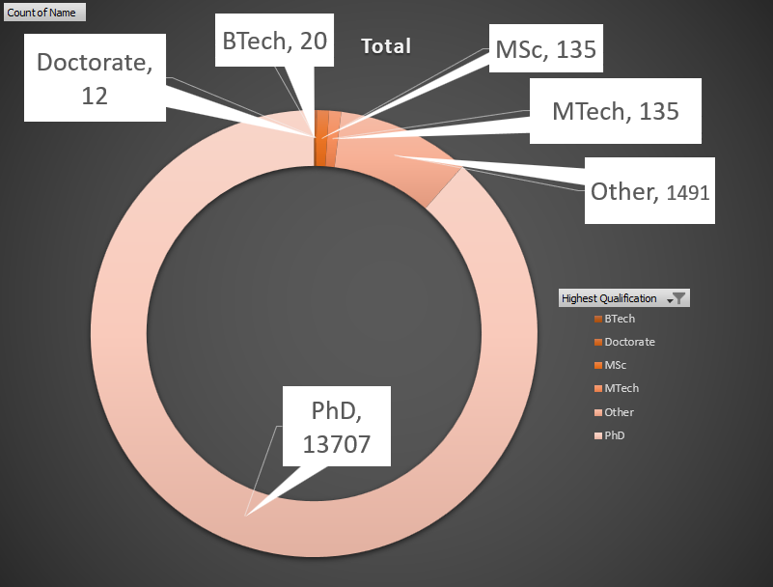
- Qualification Analysis (Pie Chart): A pie chart was utilized to visualize the proportional distribution of terminal degrees (PhD, MTech, MSc, etc.), providing a clear breakdown of the academic profile of the workforce.
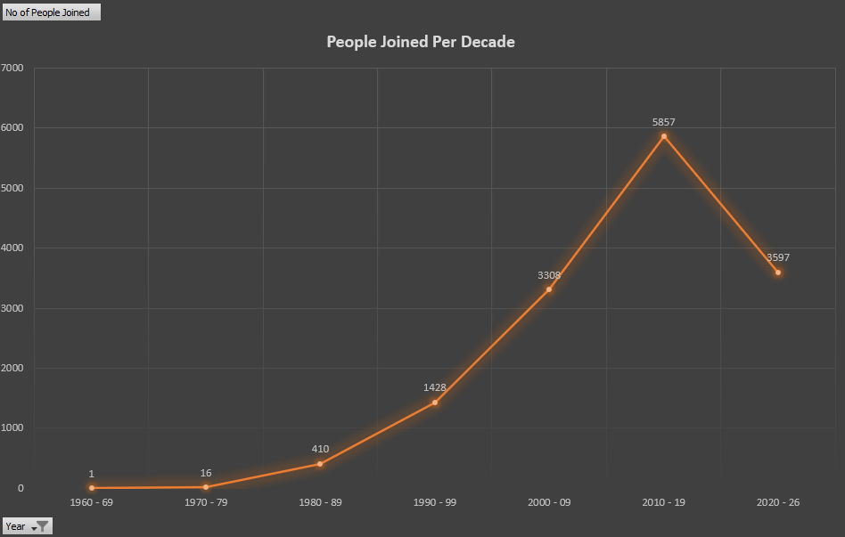
- Hiring Trends (Line Chart): A line chart was plotted against the Start Year attribute to illustrate the chronological growth and patterns in faculty recruitment over time.

7.Interactive Dashboard
The final phase involved to create an interactive dashboard:
- Scorecards: A dedicated section displaying high-level metrics, including:
  - Total Faculty Count
  - Faculty with Awards (Sum of 'Has Awards' column)
  - Average Years of Experience
- Dynamic Filtering (Slicers): Integrated interactive Slicers for University, Department, and Experience Range. These allow users to filter the entire dashboard’s visuals and tables with a single click.
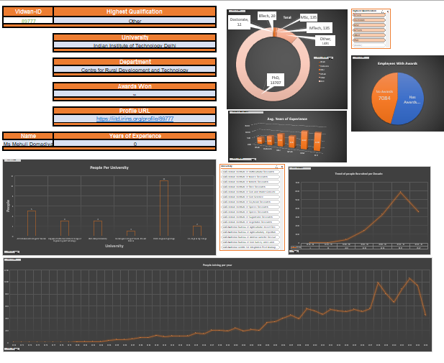
- Interactive Growth Graph: An interactive line graph that updates automatically based on slicer selections to show specific recruitment trends by department or institution.

Conclusion
This project successfully transformed a raw dataset of 15,000 records into a functional, high-integrity academic management tool. Through the systematic application of Excel’s analytical features, the following outcomes were achieved:
- Data Integrity: Multi-stage cleaning and validation eliminated 100% of redundant and inconsistent entries, establishing a "single source of truth" for faculty data.
- Search Efficiency: The integration of VLOOKUP search engines and multi-level sorting reduced data retrieval time from minutes to near-instantaneous results.
- Visual Intelligence: The interactive dashboard converted complex categorical data into actionable insights, providing a clear overview of recruitment trends, qualification distributions, and institutional benchmarks.
Ultimately, this system provides a scalable framework for academic data analysis, enabling stakeholders to navigate large-scale institutional information with precision and speed.

